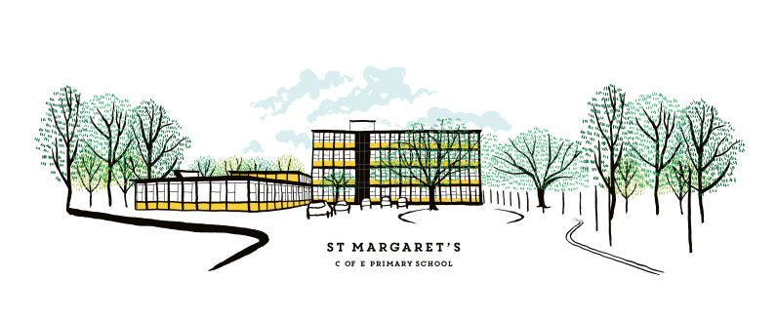
Nursery Application Form
3 year olds

All information shared will be treated as confidential

Please present your child’s birth certificate for copying and placing on file.
Pupil information
Child’s legal Surname |  | Preferred Surname
Child’s legal Forename |  | Preferred Forename
Middle name(s)
Date of birth |  | Gender
Address
Postcode |  | Telephone number

Parent / Carer information (We are required to record the names and addresses of every person who has parental responsibility for the child under the Children Act)
Title |  | Mr☐ Mrs☐ Miss☐ Ms☐ Dr ☐ |  |  | Title | Mr☐ Mrs☐ Miss☐ Ms☐ Dr ☐
Name |  |  |  |  | Name
Relationship to child |  |  |  |  | Relationship to child
Address |  |  |  |  | Address
Postcode |  |  |  |  | Postcode
Telephone numbers |  |  |  |  | Telephone numbers
Mobile |  |  |  |  | Mobile
Home |  |  |  |  | Home
Work |  |  |  |  | Work
Email |  |  |  |  | Email
If the child does not live with both his/her parents, please advise if there is a court order concerning the child. Yes ☐ No ☐

Please give details of any siblings at St Margaret’s CofE Primary
Name |  | Class
Name |  | Class
Name |  | Class

For Office Use Only
Proof of age provided and checked
Evidence of proof of address provided and checked
Preferred place
We offer full time or part time places in our Nursery. Full time places are 30 hours and part time places are 15 hours. Part time places can either be morning or afternoon sessions.

For a full time/30 hours place you will either need to quality for a code from the Government or pay the additional hours fee of £75 per week

For more information, please visit this website: https://beststartinlife.gov.uk/eligibility-checker/

In addition to having a 30 hour code or paying the fee, the school may offer a full-time place at their discretion based on individual circumstances.

If you need support to find out if you qualify for an additional 15 hours please speak to the school office.

Please indicate below the type of place you would like for your child:
Full time? | Yes ☐ | How will you pay? | 30 hours code ☐ Additional hours fee of £75 per week ☐
Part time? | Yes ☐ | Session required? | AM session (8.45-11.45) ☐ or PM session (12.15-3.15) ☐

Medical conditions / SEN
Please tick if your child suffers from any of the following:

Arthritis ☐ Asthma ☐ Allergies(*please specify below) ☐ Diabetes ☐ Eczema ☐ Epilepsy ☐

Hayfever ☐ Heart problems ☐ Hearing impairment ☐ Visual impairment ☐

Toileting problems ☐ Physical difficulty e.g cerebral palsy/muscular dystrophy ☐

Speech & Communication ☐ Social/ Emotional needs ☐ ADHD ☐ Autism ☐ Dyslexia ☐

Dyspraxia ☐ Downs syndrome ☐ Other ☐
*please give further information if you have ticked any boxes above (include dates of any referrals to other agencies)
Does your child require medical treatment, including medication? For example, Asthma inhaler, Epipen, antihistamine. (*please detail below). | Yes ☐ | No ☐
*

Language
What is your child’s first language?
What languages are spoken at home?

